INTERNATIONAL POLLUTION PREVENTION CERTIFICATE FOR THE CARRIAGE OF NOXIOUS LIQUID SUBSTANCES IN BULK

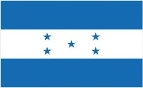
Issued under the provisions of the International Convention for the Prevention of Pollution from Ships, 1973,
as modified by the Protocol of 1978 relating thereto,
as amended (hereinafter referred to as “the Convention”),
under the authority of the Government of

THE MERCHANT MARINE HONDURAS
GR CLASS CLASSIFIED FOR STANDARD (GR CLASS)

NLS No.
Name of Ship | Distinctive Number or Letters | Port of Registry | Gross Tonnage
 | IMO Number

THIS IS TO CERTIFY:

- That the ship has been surveyed in accordance with the provisions of regulation 8 of Annex II of the Convention.

- That the survey showed that the structure, equipment, systems, fitting, arrangements and material of the ship and the condition thereof are in all respects satisfactory and that the ship complies with the applicable requirements of Annex II of the Convention.

- That the ship has been provided with a Procedures and Arrangements Manual as required by regulation 14 of AnnexⅡ of the Convention, and that the arrangements and equipment of the ship prescribed in the Manual are in all respects satisfactory.

- That the ship complies with the requirements of Annex II to MARPOL 73/78 for the carriage in bulk of the following Noxious Liquid Substances, provided that all relevant operational provisions of Annex II of the Convention are observed.

Noxious liquid substances | Conditions of carriage (tank numbers, etc.) | Pollution Category
1Continued on additional signed and dated sheets

This certificate is valid until

subject to surveys in accordance with regulation 8 of AnnexⅡ of the Convention.

Issued at |  | Date of issue
 | (Place of issue of certificate) | (DD-MM-YYYY)
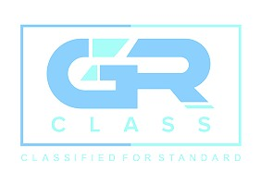

GR CLASS REPRESENTATIVE .

GR CLASS – CLASSIFIED FOR STANDARD (GR CLASS)

E-mail: info@grclass.com Web: www.grclass.com

Form NLS-ST Approved by: GM Page 1 of 1

